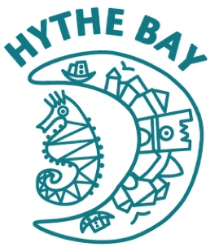
Hythe Bay Children’s Centre Nursery
Cinque Ports Avenue
Hythe
Kent
CT21 6HS

01303 267802

nursery@hythebay.kent.sch.uk

Registered Charity Number 1175752
Ofsted Unique Reference Number EY556679

Thursday 12th March 2020

Dear Parents, Carers and Staff

RE COVID-19 (Coronavirus)
At Hythe Bay Nursery, our policies and procedures regarding health and wellbeing follow guidance from the government and the National Health Service (NHS). The government and NHS have updated their advice on COVID-19. The new advice is detailed in this letter and will take effect from Friday 13th March 2020.
At this stage, there is no need to close schools or nurseries, but this may change as the disease spreads. We will update our status on the School Closure Website (www.kentclosures.co.uk) and on our social media platforms. We continue to teach children the importance of good hygiene and how to wash their hands effectively. We have also introduced a new procedure earlier this week whereby staff, parents, children and visitors are asked to wash their hands or use hand sanitiser on arrival at nursery.
Anyone with symptoms that could suggest coronavirus should self-isolate for 7 days. This means that if you or your child have a new continuous cough OR high temperature (37.8 degrees or higher) you should stay off nursery, at home, for 7 days. If you have these symptoms, please do not go to a GP surgery, pharmacy or hospital, and do not call 111 to tell them you’re staying at home. You can use the NHS 111 online service if you feel you cannot cope with your symptoms at home, your condition gets worse or your symptoms do not get better after 7 days. If you cannot get help online, you can call 111 instead.
The Department for Education coronavirus helpline is available to answer questions about COVID-19 relating to education and children’s social care. Staff, parents and young people can contact this helpline. Phone: 0800 046 8687. Email: DfE.coronavirushelpline@education.gov.uk. Opening hours: 8am to 6pm Monday to Friday.
Thank you for taking the time to read this letter. If you have any questions, please speak to a member of the management team. There has recently been a delay in our responses to emails and phone-call messages, but we endeavour to respond to these as soon as possible.
Best regards
Vicki Dumont
Nursery Manager

